**Jira Bug Tracking**

# Jira Project Dashboard:

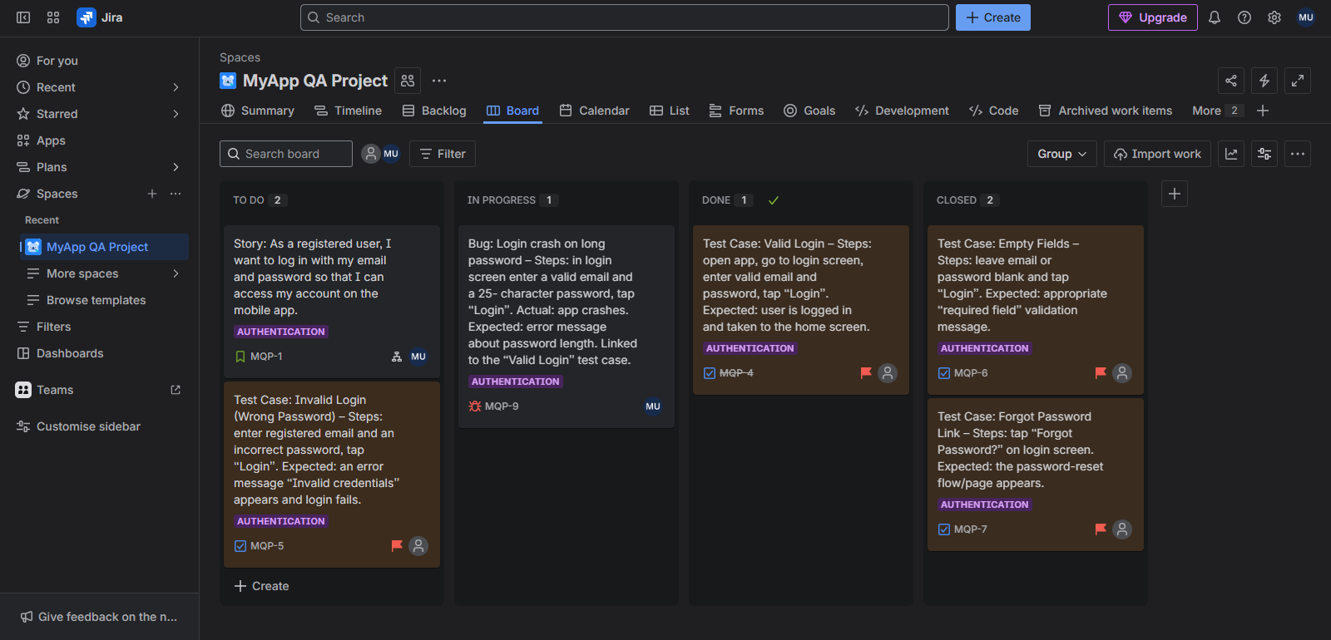

# User Story (Login Feature):

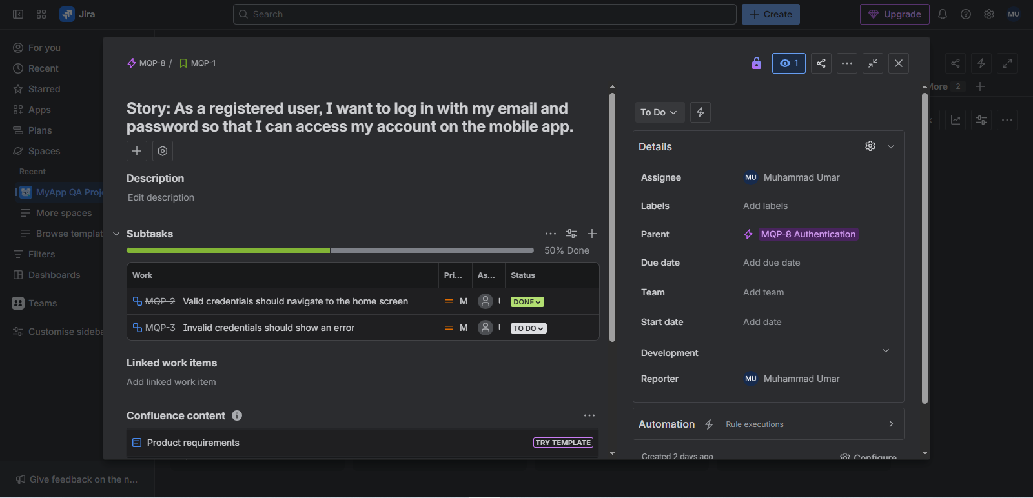

# Test Cases Created:

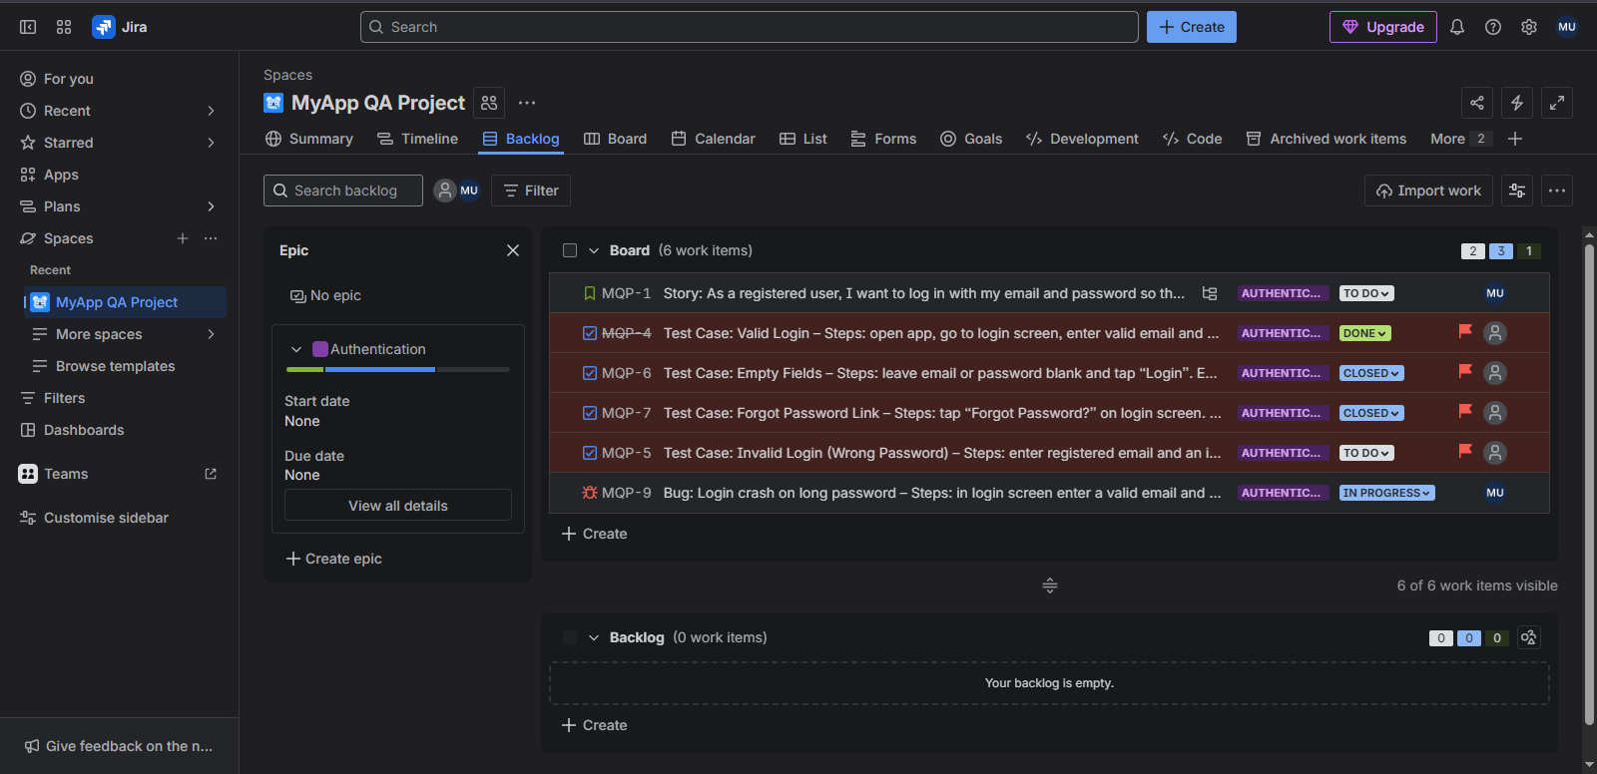

# Bug Logged with Details:

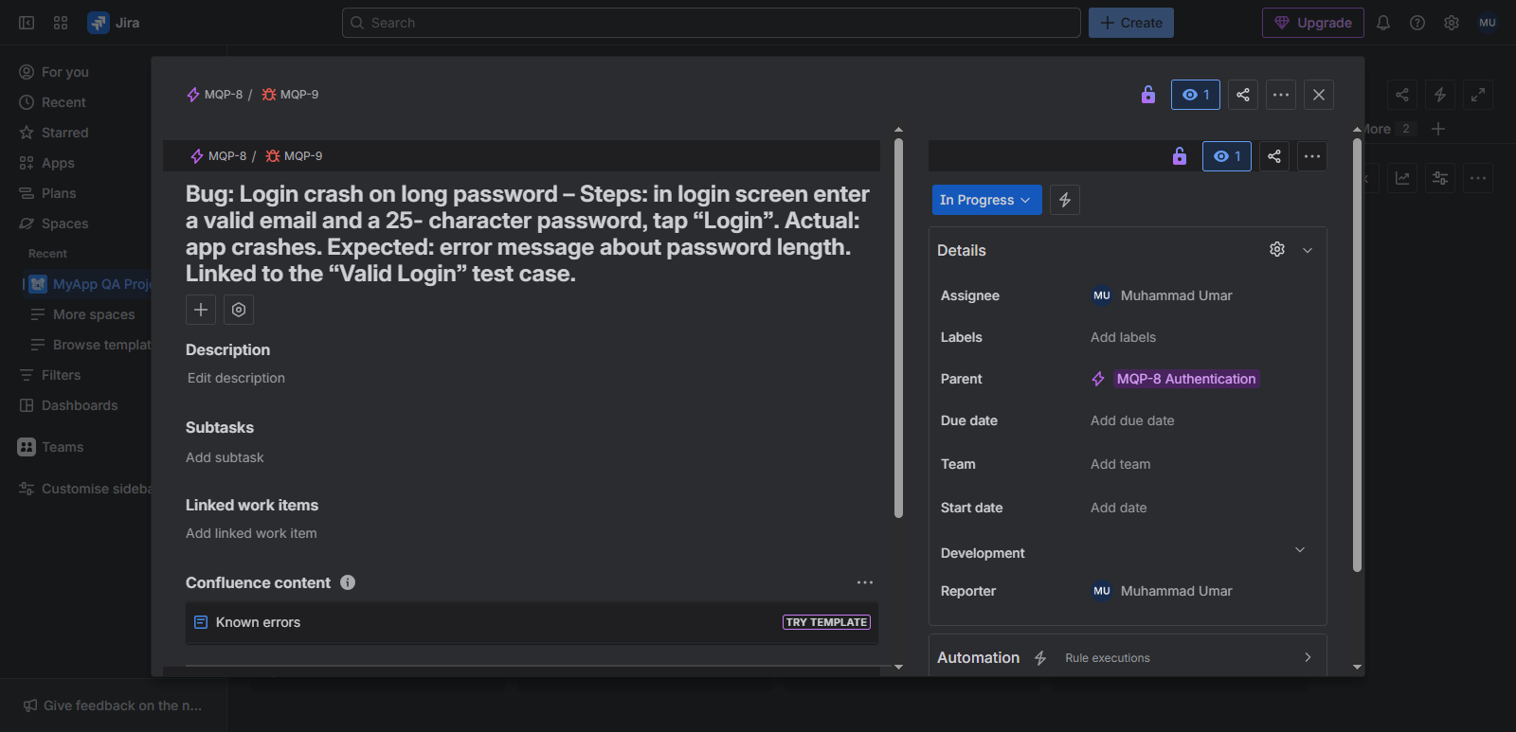

# Kanban Board – Workflow Status:

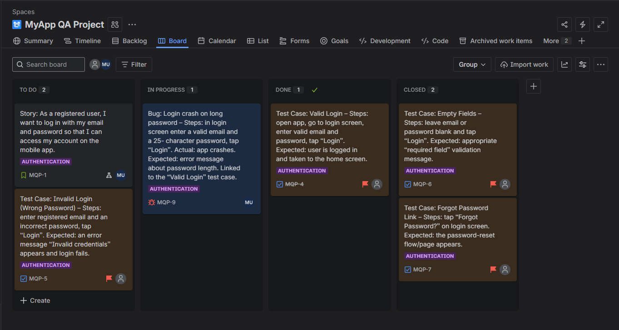

**Cross-Browser and Device Testing Report**

# Testing Setup:

Desktop tests used Chrome (latest), Firefox, Edge (Chromium), and Opera at 1920×1080. For mobile/tablet, we used Chrome Dev Tools Device Mode to simulate an iPhone and an Android tablet.  
  
Hero Section:

## Chrome:

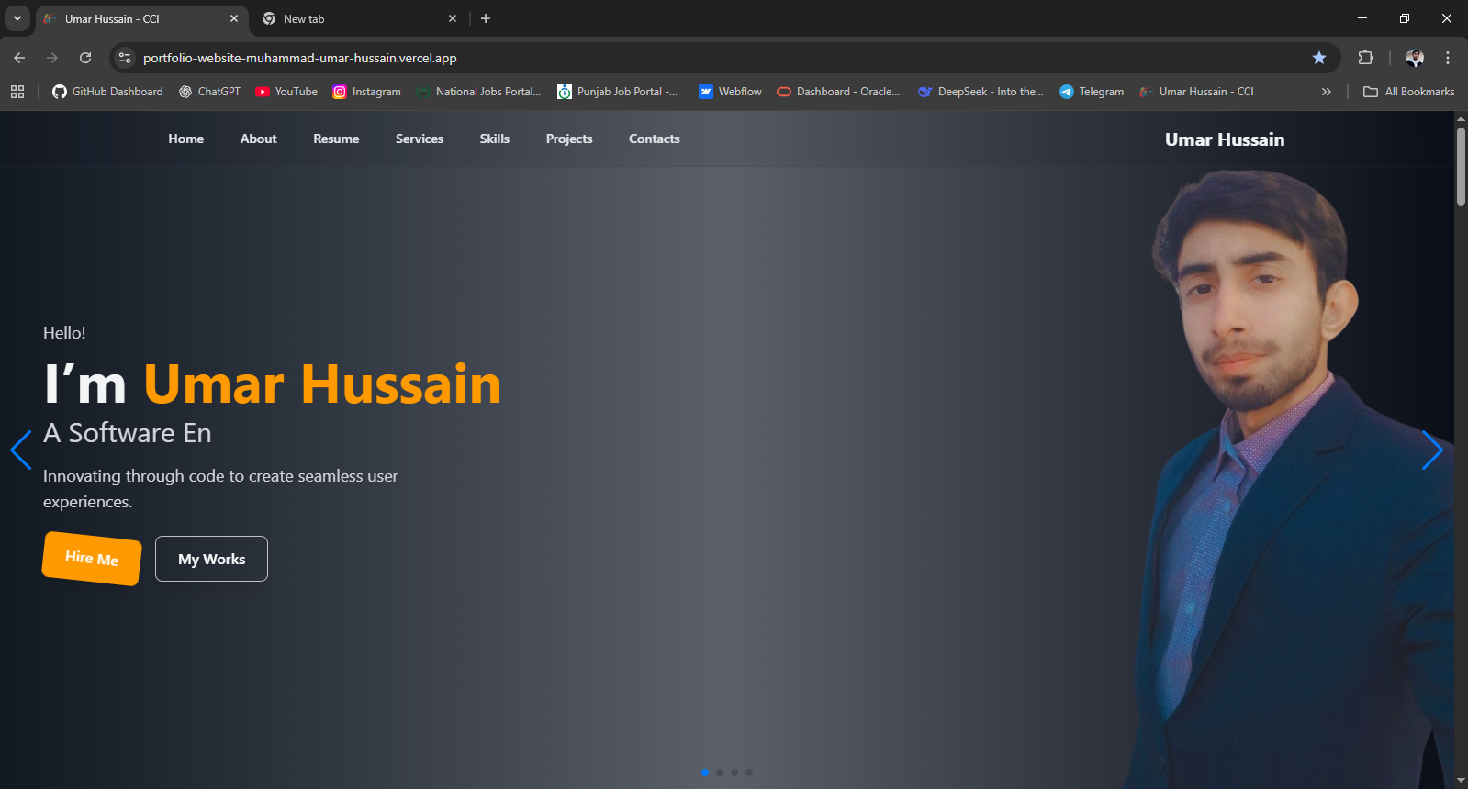

## Firefox:

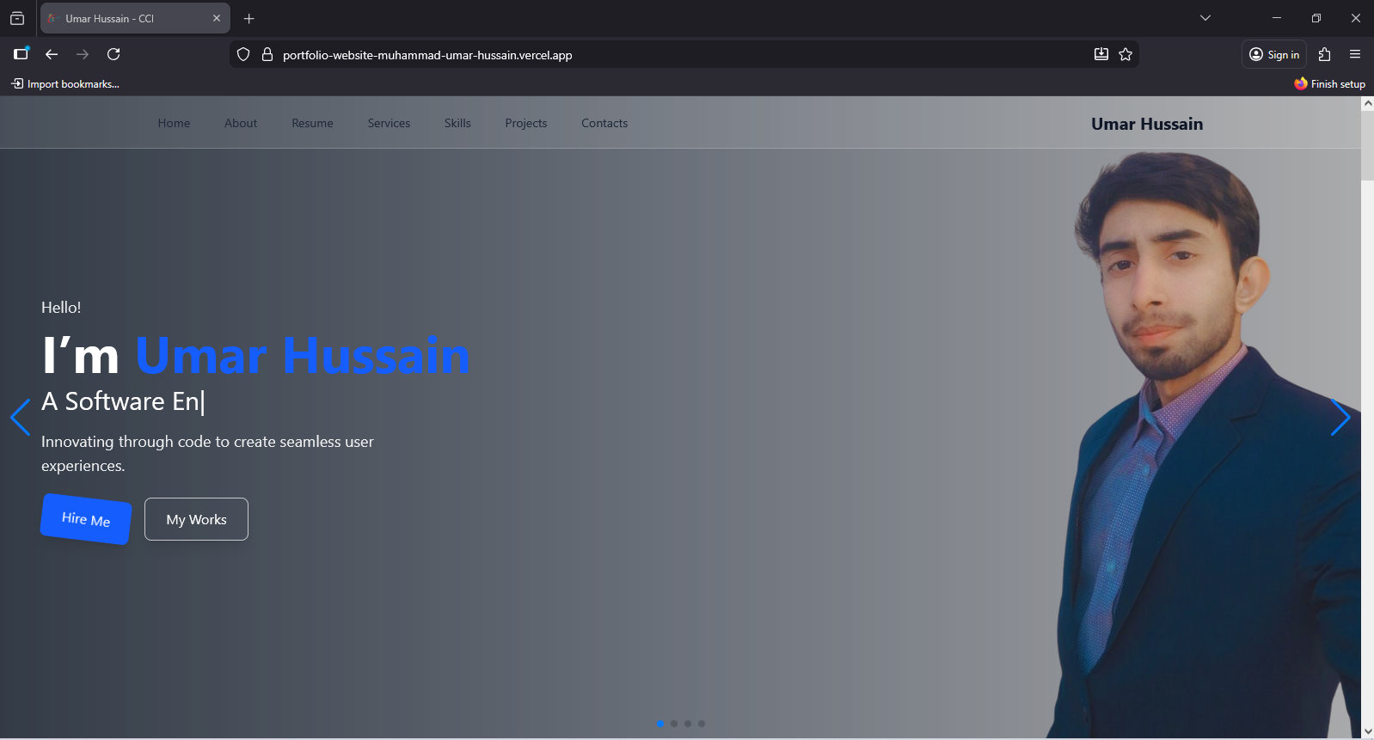

## Edge (Chromium): Opera:

## Mobile:

## Tablet:



## Conclusion:

On desktop, the hero banner (headline, subtext, background) looked *identical* in Chrome, Edge, Opera and Firefox. The text remained cantered and legible in all browsers. On shrinking the window, the hero text responsively wrapped into multiple lines without overlap or cut-off, and the background image scaled down as expected. We paid special attention to CSS layout rules: for example, using align-items: end in Flexbox can mis-align Chrome vs. Firefox (Chrome aligns to top, Firefox to bottom). Our CSS used flex-end instead, which yields uniform results in both browsers. In short, the hero section’s core content (the heading and call-to-action) remained fully accessible on every tested browser and device.

# Gallery Page:

## Chrome:

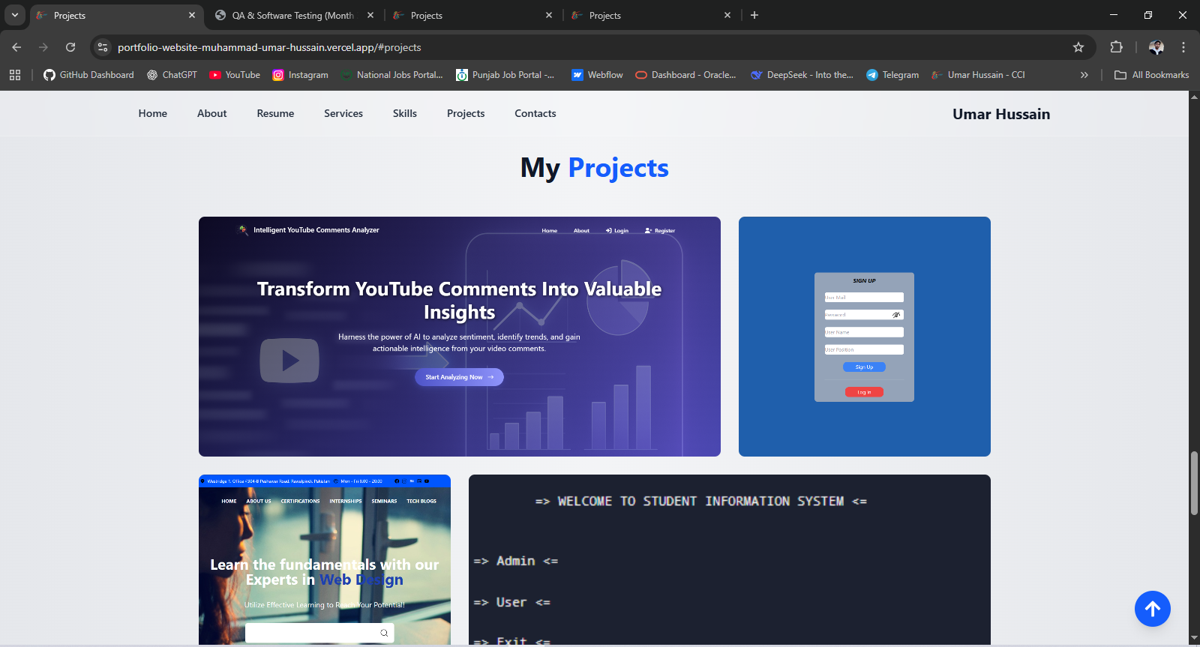

## Firefox:

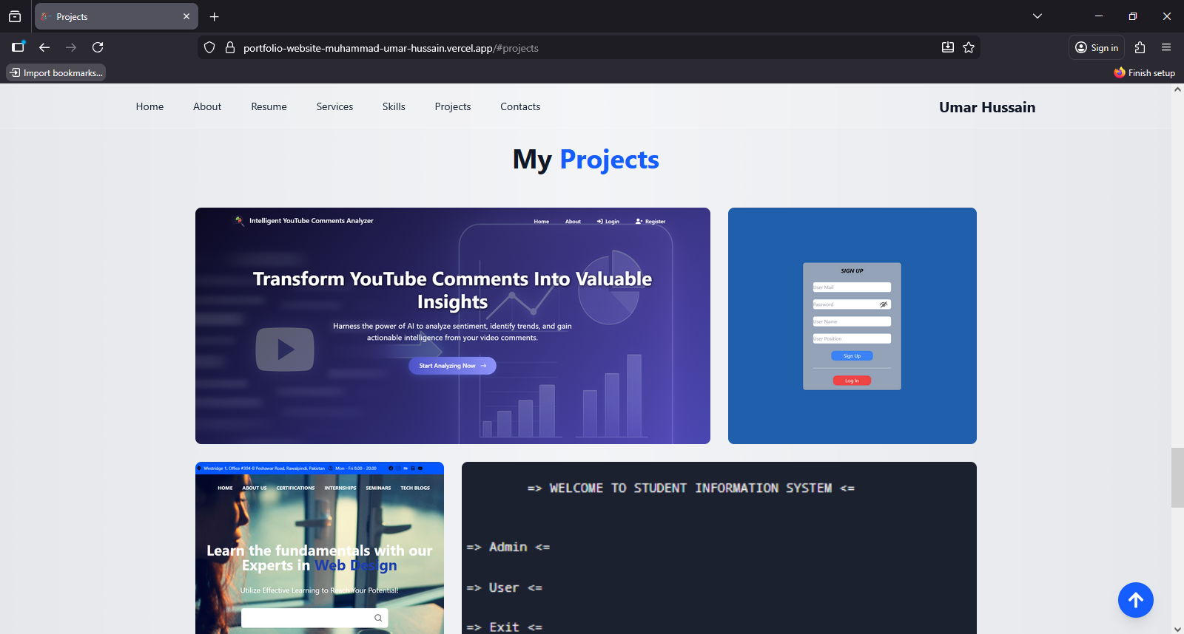

## Edge (Chromium):

## Opera:

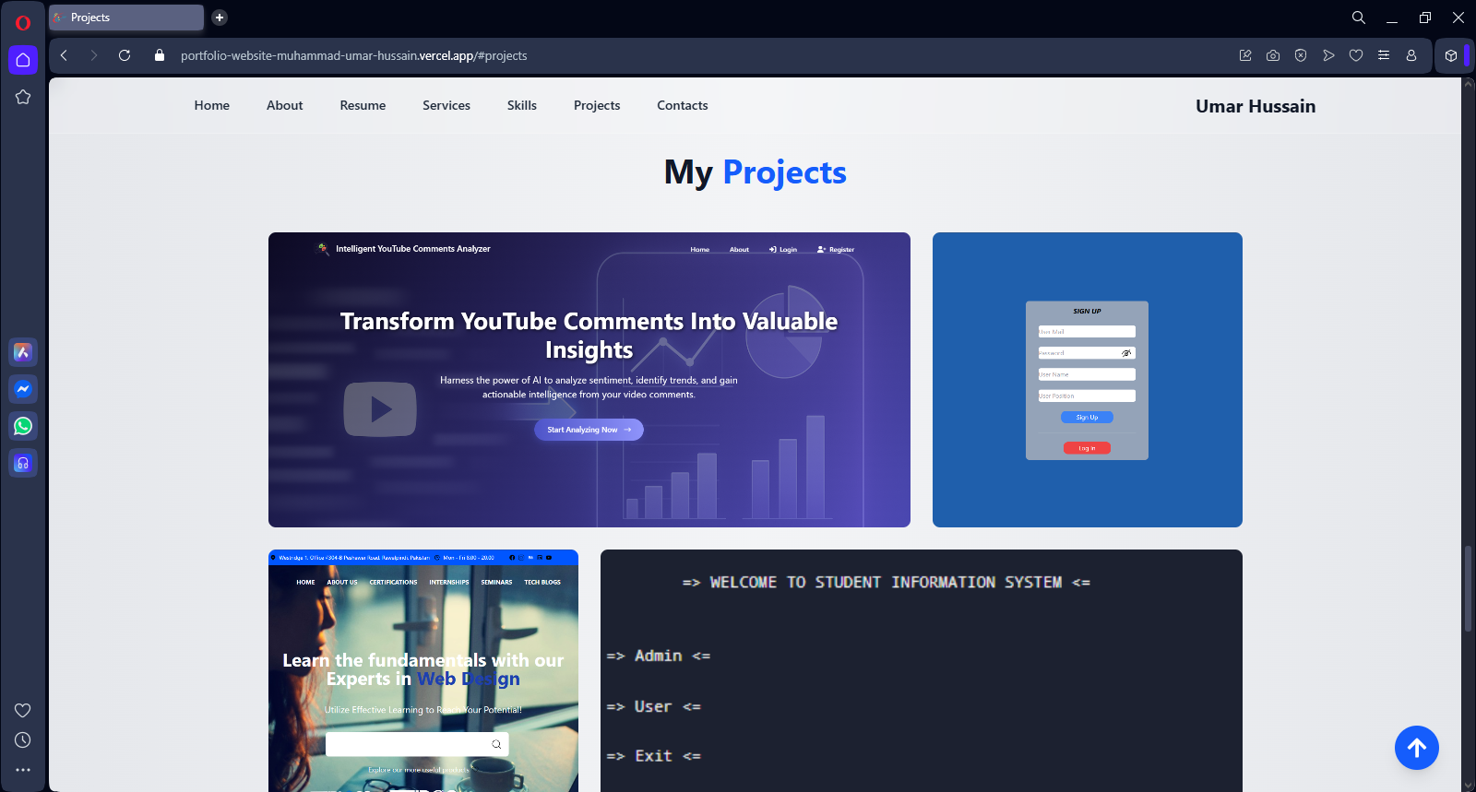

## Mobile:

## Tablet:

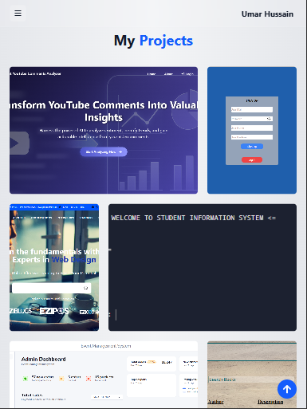

## Conclusion:

The portfolio gallery images were arranged in a responsive grid. We found that in all browsers the images maintained their aspect ratios and spacing. On desktop each row displayed the same number of columns; on tablet/mobile the grid collapsed gracefully to fewer columns or a single column so images never overlapped. No broken images or layout breaks were observed. One general cross-browser note arose: Chrome and Firefox sometimes interpret percentage-based image dimensions differently. For example, in one test setting an image to 250% width produced different results because Chrome used the parent container for the percent calculation while Firefox used the image’s own dimensions. To avoid this, we kept critical image sizes in fixed or viewport units.

# Other Components:

## Conclusion:

We also checked the navigation menu, buttons, and links. On narrow screens the menu collapsed into a mobile-friendly toggle (or stacked vertically) in all browsers. Buttons and links responded to clicks and taps identically across browsers; forms (if any) submitted correctly. There were no functional bugs or JavaScript errors in any browser. Importantly, we verified that no elements overlapped or became hidden at any screen width – aligning with the advice that “no elements overlap and the navigation is user-friendly”. All interactive features (e.g. opening a project detail from the gallery) worked on every browser and device we tried. Overall, the site’s functionality is consistent: the same actions (clicks, form submissions) have the same results everywhere.

| **Browser / Device (or Engine)** | **Observed Behaviour / Notes** | **Issues (if any) / Quirks** |
| --- | --- | --- |
| **Blink-based (Chrome / Edge / Opera) — Desktop** | Layout & styling consistent across all three; hero section and gallery render as intended; styling and grid layout same across browsers. | None — rendering and layout stable. |
| **Blink-based (Chrome / Edge / Opera) — Mobile / Tablet (simulated)** | Responsive layout works — hero scales, gallery stacks appropriately; tap/click interactions functional; no overflow or broken styling. | None significant. |
| **RR** | Layout and styling very similar to Blink-based — hero & gallery align correctly; fonts/colours as expected. | Minor CSS quirks possible: depending on CSS choices (e.g. percent-based image widths, flexbox alignment) layout could shift slightly. Consistency maintained after tweaks. |
| **Cross-Engine Comparison (Blink vs Gecko)** | Overall consistent rendering across engines for tested layouts and CSS rules. Using modern, well-supported CSS (flexbox/grid) ensures compatibility. | Theor r/legacy etical risk: olde browsers or edge-case CSS may behave differently; percentage-based sizing or advanced flexbox/grid could diverge. |